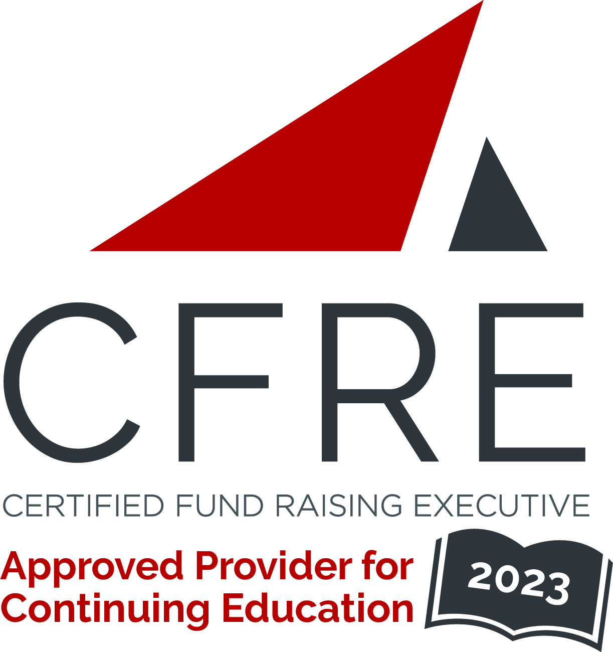  CFRE International has developed this form as a way for you to quickly track (and keep in your files!) the continuing education sessions you have attended. Simply check the boxes next to the sessions you attended. At the end of the conference, add up the total number of hours. Keep this sheet and you will be ready to complete your application form. All of the session slots listed are eligible for continuing education points on your CFRE application for initial certification and/or recertification. Sessions not listed here are not eligible for points. |  | CONTINUING EDUCATION POINTS TRACKER

Activity Organizer: - Association of Donor Relations Professionals
Title of Activity: - 2023 ADRP Northeast – Mid-Atlantic Regional Conference
Names of Presenter(s): - Various
Dates and Location: - 20 July, 2023 – South Orange, NJ USA

Date: 20 July, 2023
Session 1: 9:00am – 10:30am (1.5 pts)
- Keynote - Inspired and Inspiring: Discovering How to Tap into Your Strengths

Date: 20 July, 2023
Session 2: 10:45am – 11:45am (1 pt)
- Every Donor Has a Story
- Unlock Your Potential: Master Unstuckness
- Acknowledgments Made Easy

Date: 20 July, 2023
Session 3: 1:00pm – 2:00pm (1 pt)
- Can You Feel It? Using the Experience of Physical Spaces to Celebrate Community
- From Newbie to Mid-level to Seasoned Veteran: Career Phases
- Establish and Leverage Metrics for Growth – Yours and Your Organization’s

Date: 20 July, 2023
Session 4: 2:15pm – 3:15pm (1 pt)
- UNSESSION: Donor Relations – Past, Present, and Future
- Lighten Your Load: Working with Consultants and Freelancers
- Streamlining Stewardship Reporting

Total number of points attained: __________

