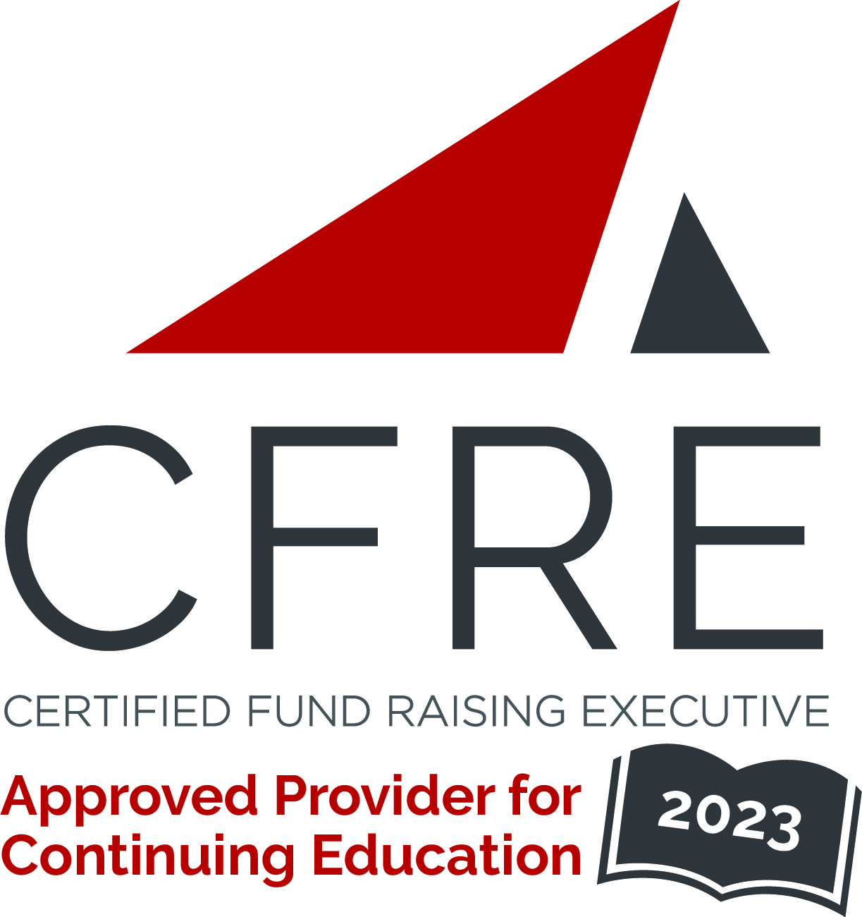  CFRE International has developed this form as a way for you to quickly track (and keep in your files!) the continuing education sessions you have attended. Simply check the boxes next to the sessions you attended. At the end of the conference, add up the total number of hours. Keep this sheet and you will be ready to complete your application form. All of the session slots listed are eligible for continuing education points on your CFRE application for initial certification and/or recertification. Sessions not listed here are not eligible for points. |  | CONTINUING EDUCATION POINTS TRACKER

Activity Organizer: - Association of Donor Relations Professionals
Title of Activity: - 2023 ADRP Midwest Regional Conference
Names of Presenter(s): - Various
Dates and Location: - 27 July, 2023 – Evanston, IL USA

Date: 27 July, 2023
Session 1: 9:00am – 10:15am (1.25 pts)
- Keynote: Being the Story Guardian

Date: 27 July, 2023
Session 2: 10:45am – 11:45am (1 pt)
- Marketing is Impact
- Pandemic Pivot, Digital Disrupt, Engagement Evolve

Date: 27 July, 2023
Session 3: 1:15pm – 2:30pm (1.25 pts)
- Panel Discussion: Principles of Diversity, Equity, and Inclusion in Donor Relations

Date: 27 July, 2023
Session 4: 3:00pm – 4:00pm (1 pt)
- Recognition Refresh
- The Secrets of Great Stories

Total number of points attained: __________

